1. Date has been captured on the receipt i.e. “Expected receipt date” and “Actua Arrival date”

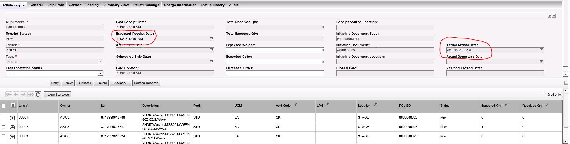

1. After saving this, the information disappears. \
2. 